Join the award-winning JBHS Drama Department for THE ILIAD, THE ODYSSEY AND ALL OF GREEK MYTHOLOGY (In 99 MINUTES OR LESS) on May 10 at 7pm, May 11 at 7pm or May 12 at 2pm. General seating is $15; Student and Senior seating is $10 and MIDDLE SCHOOL STUDENTS are FREE (with ID!) This is madcap fun for the WHOLE FAMILY!
With the clock ticking in front of everyone's eyes, this hilarious farce races through all of Greek Mythology in just under 99 minutes! In this easy to understand comedy, you will see Gods and Goddesses walk the red carpet, learn about the creation of mankind and how the gods botched it up, and witness Pandora's fateful decision to open that ominous box! Famous love stories are presented like dating shows and Greek Wars and tragedies are presented like sporting event highlights, with costume changes and madcap mayhem! And don't forget the two greatest stories ever told! In The Iliad, Helen of Troy gets kidnapped, leading to a ten-year slap-fight of epic proportions followed by The Odyssey where Odysseus attempts to get home for another ten years while fighting seductresses, monsters, and even the Gods themselves! You won't be able to keep from laughing as these zany characters present all of the myths with lightning speed in this hysterical spoof with only seconds to spare!
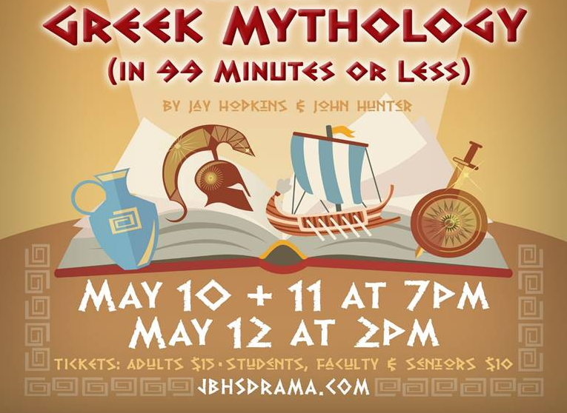

Oscar Macias, Ed.D.
Principal
Luther Burbank Middle School

